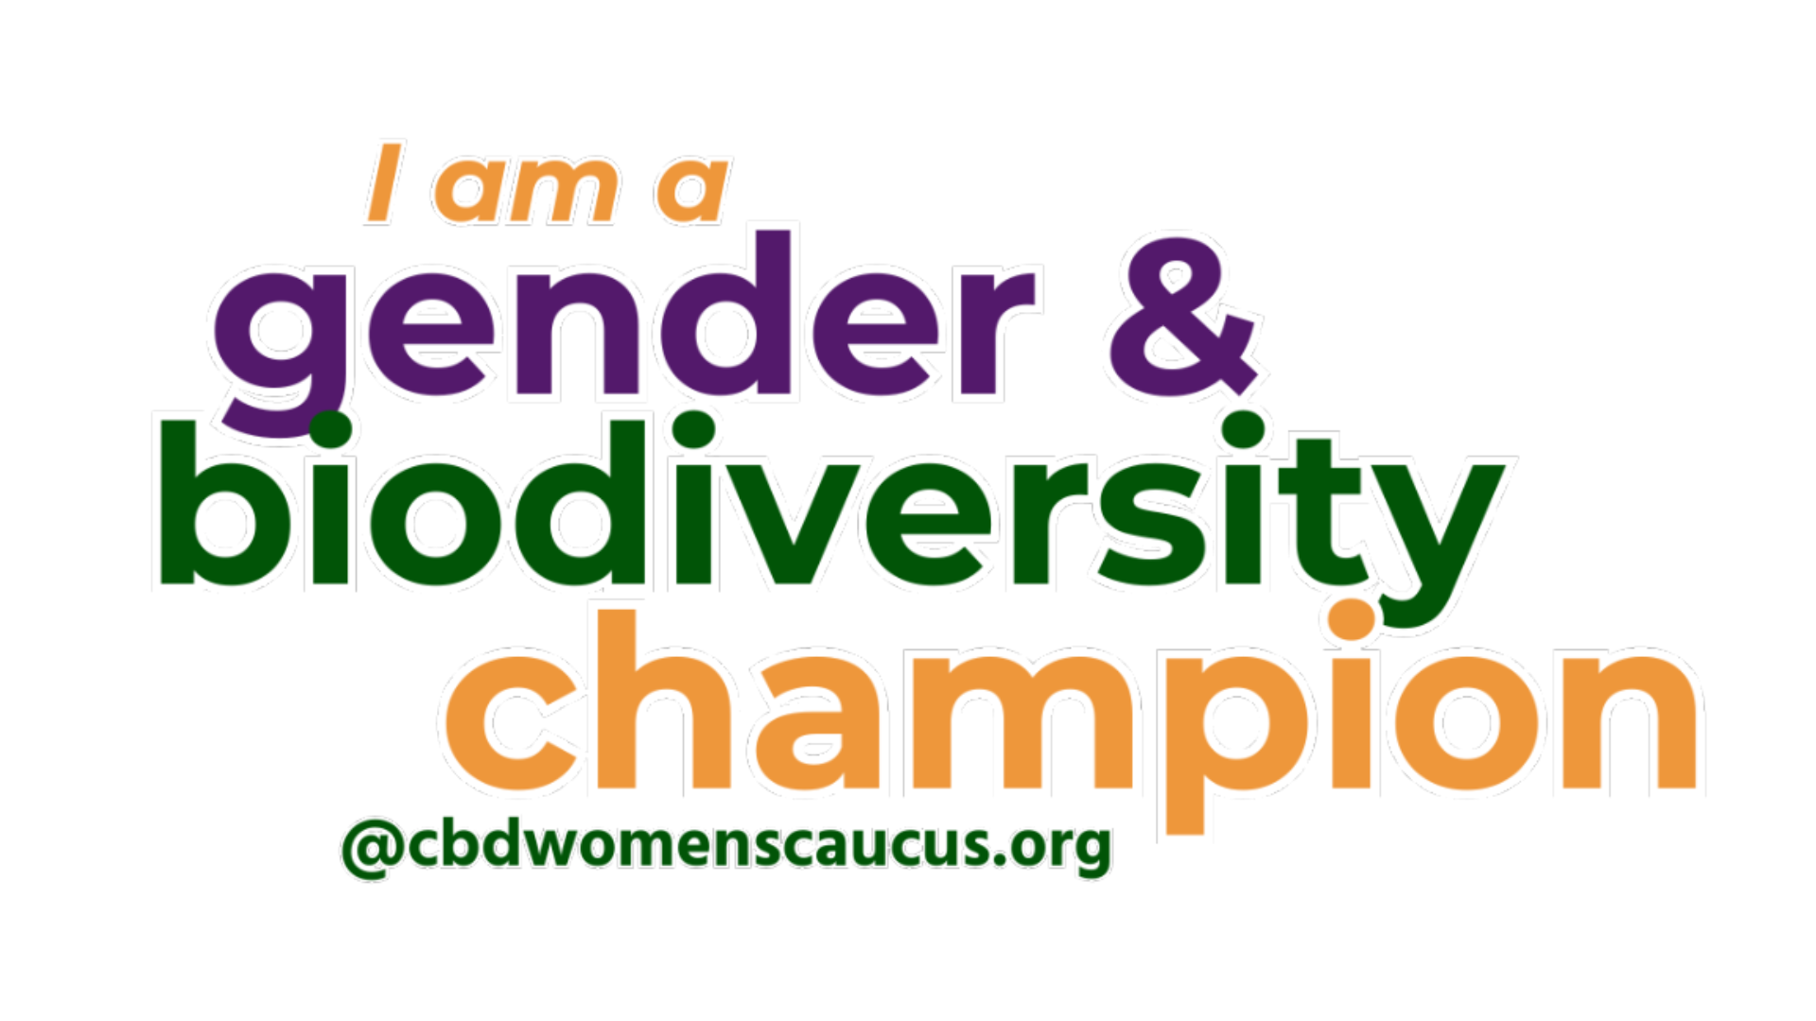

Gender & Biodiversity Champions

Offline subscription form

The **Gender and Biodiversity Champions** platform is an initiative of the **CBD Women's Caucus**, created to drive the full and timely implementation of the [**Gender Plan of Action (GPA)**](https://www.cbd.int/doc/decisions/cop-15/cop-15-dec-11-en.pdf) under the **Convention on Biological Diversity (CBD)**.

Launched at COP16, this global coalition unites high-level representatives from women’s organisations in all their diversity, governments, international organisations, private sector, academia,Indigenous Peoples, local communities, and civil society to commit to gender-responsive biodiversity actions.

**All questions are mandatory.**

1. **Email**
2. **Full name**
3. **Country**
4. **Affiliation**
5. **Description of your commitment as champion**
   1. Explain what actions are you committing to implement, and make sure to mention how it is related to the [CBD Gender Plan of Action](https://www.cbd.int/doc/decisions/cop-15/cop-15-dec-11-en.pdf).
6. **Profile picture**
   1. Make sure to attach a profile picture when sending this form by email.

For further engagement contact us at coordination@cbdwomenscaucus.org using [G&B Champions] in the subject line.